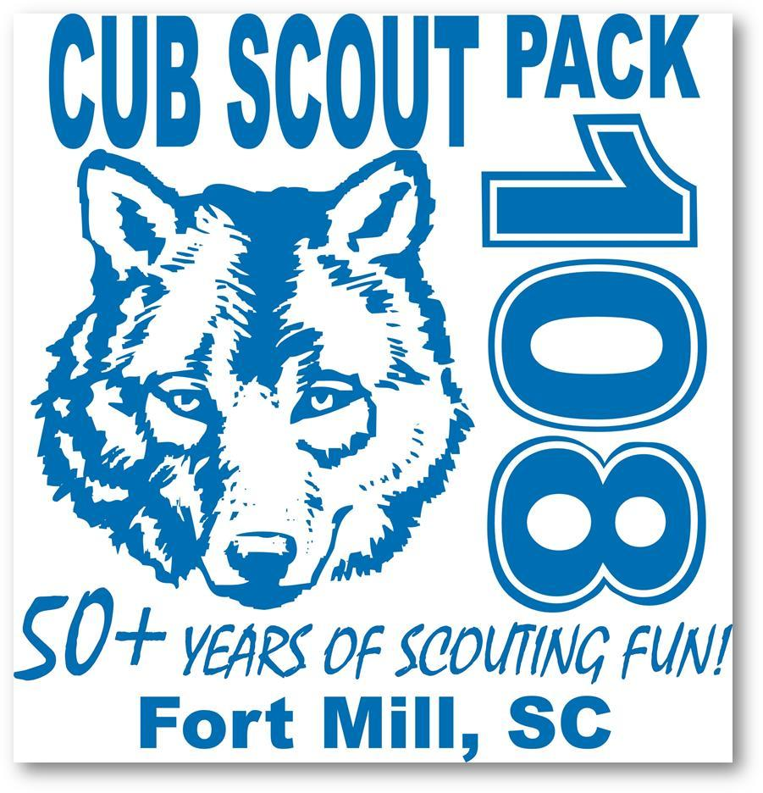
Pack 108
Parent’s Handbook

V2019
Welcome to Cub Scout Pack 108!
We are so excited that you have chosen to enter the world of Scouting through our pack. You and your Scout will be glad you did. We have an exciting program full of learning and fun.

This handbook was designed to provide new members an introduction to Cub Scouts and Pack 108. If you have any questions, please call on one of the Pack Leaders. You can also visit our website www.pack108.com.

Cub Scout Pack 108, of Fort Mill, South Carolina, has been chartered for over 50 years! Our Charter Organization is Unity Presbyterian Church. We are part of York District, one of the three Districts in the Palmetto Council. Palmetto Council includes the following counties: Spartanburg, Chester, Cherokee, Union, York, and Lancaster. Palmetto Council has a strong program that provides many activities and camps for Scouts.

Pack 108 is a very active Pack. We are proud of our tradition of monthly activities, regular advancement and recognition for Cub Scouts, parent volunteers, and Summertime activities and awards.

Introduction to Cub Scouting

Cub Scouting is a year-round family program of the Boy Scouts of America for boys and girls in kindergarten through fifth grade.

The mission of the Boy Scouts of America is to prepare young people to make ethical and moral choices over their lifetimes by instilling in them the values of the Scout Oath and Law.

There are four aims of Scouting: citizenship, character, personal fitness, and leadership.

The methods of Cub Scouting are: living the ideals, belonging to a den, advancement, family involvement, activities, serving the community, and the uniform.
General Information

Rank
Scouts are placed in Ranks based on their school grade. The ranking year goes from June to May.

Lion Cubs
Kindergartners who are 5 by September 1st

Tiger Cubs
First graders (have completed kindergarten)

Wolf Cubs
Second graders (have completed 1st grade)

Bear Cubs
Third graders (have completed 2nd grade)

Webelos
Fourth graders (have completed 3rd grade)

Arrow of Light (AOL)
Fifth graders (have completed 4th grade)

All new Scouts, Tiger and above, must earn their Bobcat badge at the beginning of their first Scouting year.

Participation
A Cub Scout will generally have one Scouting event each week during the school year. Scouts are expected to attend:

Den Meetings - held weekly during the school year. Days and times are determined by the Den Leaders and Parents.
Pack Meetings - typically held the 3rd Thursday of each month during the school year.
Pack Activities - scheduled year-round.

Calendars are available on-line and are handed out at the beginning of the year.

All family members are welcome and encouraged to participate in Den and Pack events. Cub Scout activities are not “drop-off” activities. Please read the “Family Involvement” section for more information on the role of parents and family members in the Scouting experience.

While we don’t track attendance, your Scout will get the most out of the program by attending and participating in as many events and activities as possible.

Uniforms
Field Uniform (Class As)
Cub Scout uniforms serve a dual purpose: demonstrating membership in the group (everyone is dressed alike) and individual achievement (Scouts wear the badges they’ve earned). Wearing the uniform to meetings and activities also encourages a neat appearance, a sense of belonging, and good behavior. We require all Scouts to wear their uniforms to Den and Pack Meetings. Our Pack requires uniforms from the waist up. This includes hat, shirt, neckerchief, slide, and belt. Uniform bottoms are optional. Scout handbooks are also required.

Uniforms and handbooks can be purchased online at www.scoutshop.org.

You can also go to the Scout Shop, 2121 Westinghouse Blvd, Charlotte (704) 583-2627.

Activity Uniform (Class Bs)
Activity t-shirts are available for informal events such as camping and messy, fun activities. Pack 108 t-shirts are given to each new Scout. Additional shirts for Scouts, siblings, and parents may be ordered twice a year.

Parent’s Uniform
While not mandatory, all parents are encouraged to support the pack spirit by wearing the Pack 108 t-shirt to Cub Scout events. Even wearing the blue & gold Cub Scout colors will lend to the festivities. Many parents wear the “Proud Parent Ribbon” that displays the ranks that their scouts have earned.

Leader Uniform
Adult Leaders wear the appropriate Cub Scout Leader uniform to all Den and Pack meetings and activities. Leaders set the example for the Scouts to follow.

Uniform Expenses
As of 2019, the Field Uniform, as required by Pack 108, costs approximately $65. Additional pieces such as pants and socks will be extra. Handbooks run $17.

We believe that uniforms and related costs should not be a barrier for a child to join Scouts. Pack 108 has a “uniform closet” to help families who are unable to purchase a new uniform. As Scouts grow, some families donate old uniforms and handbooks. These are available to those in need.

Scouts that bridge up to the next rank in the Pack and plan to return to scouting in the fall are awarded their next rank handbook when they bridge.

Pack Structure
Like every effective organization, Cub Scout Packs have structure. Understanding this structure and how it works will increase your Scout’s enjoyment of the program (and leave the parent far less confused).

Dens
A Den is a small group of Cub Scouts who are the same gender and in the same grade. The ideal size is 6 to 8 Cub Scouts. An adult, usually a parent, serves as a Den Leader. They carry out the activities related to adventures as they are presented in the Cub Scout’s handbook and the Den Leader Guide.

The Dens are organized by rank and are numbered. Pack 108 has one or more Dens for each group of Lions, Tigers, Wolves, Bears, Webelos and Arrow of Light. Girls and boys of the same rank will be in separate Dens.

Pack
The Pack consists of the Dens and their families. Pack 108 holds a monthly Pack Meeting, usually at 6:45 pm on the 3rd Thursday of each month during the school year. The meeting is held in the Fellowship Hall of Unity Presbyterian Church. The Pack also conducts numerous extra activities that are listed in this handbook under the Special Teams for Pack 108.

The leader of the pack meeting is the Cubmaster. In addition to serving as the master of ceremonies, the Cubmaster provides support to Den Leaders.

Pack Committee
The Pack Committee consists of Den Leaders, Cubmaster, Assistant Cubmasters and other volunteer parents who are charged with managing the Pack and its programs. Positions include: Committee Chair*, Treasurer*, Trainer, Advancement*, Media, Fundraising, Outdoor Activity, Membership, Public Relations, Friends of Scouting, Scribe*, and Charter Organization Representative*. (*minimum required for Pack)

The Pack Committee Chair works with the Cubmaster to lead the group in planning and organizing the Pack program. The Committee is also responsible for maintaining Pack funds and planning its budget.
The Pack Committee meets for Parents’ Night. All parents are welcome and encouraged to attend. Parents’ Night is usually the 3rd Tuesday of each month during the school year. We typically meet in the Youth Wing of Unity Presbyterian Church, although some months we meet off-campus.

Special Teams
Adult volunteers are the essential ingredient in running a quality Cub Scout Pack program. Our Pack has many Special Teams for the events and activities your Scout will participate in. These Teams give you ample opportunity to volunteer for a project that you are interested in. Most Teams are for events that happen once a year. This makes it easier for those who cannot commit to a year-long position. Each family is expected to volunteer for at least one Special Team. The list of Special Teams is included in this handbook.

Registration
Basic membership in Pack 108 for a full year, January through December, is only $135. AOL Scouts will pay $95. New Scouts joining at the beginning of the school year will pay $40 to the Pack plus $15 in BSA fees.

Dues include: the cost of being a Scout (awards, pins, loops, etc.), Scout dues to BSA, Leader dues to BSA, Gold Rush Campout (Scout + one adult), Den Requirement costs.

Scouts and families have the opportunity through fundraising to pay for part or all of the dues. More information on this is covered in Fundraising under Trails End Popcorn.

Financial aid is available to families who cannot afford to pay the registration fees. Any child who wants to participate in Scouting will not be turned away merely for financial reasons. Please contact the Pack Committee Chair or Cubmaster if you are interested in a scholarship.
Fundraising
All pack members are expected to participate in this critical part of Scouting. We want to remind parents that fundraising has an important role in Scouting. Pack 108 has traditionally helped the community year-round, including the annual “Scouting for Food” drive and Pack and Den conservation projects. Fundraising is the way that the community can support the Pack. You’ll find that members of this community are very supportive of our efforts.

Registration fees pay only a fraction of the true cost of Scouting at all levels, including activities and events. Fundraising helps to cover:

Holiday Party Blue & Gold Celebration
Camping Pinewood Derby
Bridging Ceremony Crossover Ceremony
Beach Sweep Campout Scout Dues for Top Sellers
Whittling Chip Conservation Projects
Training Scout Assistance
Scout Sunday And so much more!

Trails End Popcorn
The annual Trails End Popcorn fall fundraiser supports the national Scouts BSA, the Palmetto Council and the York District as well as Pack 108. Popcorn is our biggest fundraiser and the one we rely on the most. Our pack typically sells more than $30,000 of popcorn each year.

The Pack will pay half dues for all Scouts who sell $400 in popcorn.
The Pack will pay whole dues for all Scouts who sell $700 in popcorn.
The Pack will pay whole dues and $40 trip credit for all Scouts who sell $1,000 in popcorn.

In order to support the Scouts and popcorn sales, the Pack organizes several “Show & Sells” as opportunities to sell popcorn.

Scout Cards
Scouts have an opportunity to earn money for their “Scout Account.” Pack 108 participates in Scout Card sales with York District. Scouts sell these coupon cards for $10 to people in the community. The Scout earns $5 for each one sold. This money can then be used towards Pack activities such as campouts or overnights.

Spirit Nights
Our Fundraising Team arranges several Spirit Nights a year. These are a great way to get together as Pack families and raise a little money while having fun.

Family Involvement
Parents
Scouting is designed to provide opportunities for families to work and play together, to have fun together, and to get to know each other a little better. Parents are an integral part of the Scouting experience. Many of your Scout’s activities will take place in the home. There is even an opportunity for families to earn a Scouting award together.

You also play a big role in the Den. Parents need to attend meetings, not just to help out, but also to be with your Scout. Please share your ideas and talents. We will call on you to be involved. Please be receptive to ways that you can help out your Scout’s Den and Pack.

Parent Volunteers
Who runs the Pack? You do! You and other parents who are interested in helping young Scouts excel in a quality program. It is truly an all-volunteer force. The Pack program is divided into small, medium, and large roles. This gives everyone a chance to help out as much as they can. If every parent volunteers to lead, assist, chair, co-chair, or co-ordinate, then no one person has to bite off more than they can chew. And that means a quality program for your Scout!

Volunteer positions include Den Leaders, Assistant Den Leaders, Committee Team Members, Special Team Members, and more. Just ask how you can help!

Siblings
We know that it may be difficult for parents to attend meetings without siblings “in tow.” Remembering that the meeting is for your Scout to learn and grow, we welcome siblings when possible. Den Leaders plan crafts and activities for the Scouts. Please bring things for your other children to enjoy, and we will do our best to include them in our activities when appropriate. Please do not expect Den Leaders to babysit siblings.

“Sibling Sitters” are provided at Pack Meetings. Each month a different rank is responsible for being “Room Monitors”. This includes rearranging the Fellowship Hall before and after the Pack Meeting, as well as providing Sibling Sitters.

Adult Registration and Training
Pack Leaders and other adult volunteers are required to register with the BSA. Required adult leader registration is paid for by the Pack and is necessary for building tenure for adult award recognitions. We need registered leaders to help us give our Scouts a quality program.

Youth Protection Training (YPT)
All Leaders and parents are required by Pack 108 to complete Youth Protection Training. This training shows the importance of protecting all of our youth and gives insight as to why we follow certain rules. YPT is a very serious and important part of the BSA program that is currently offered online at my.scouting.org. YPT must be updated every two years.

Leader Training
Pack Committee members, Cubmaster, Den Leaders and Assistants have additional training requirements that will be paid for by the pack. You do not have to pay to be a volunteer!

Position-specific training is at my.scouting.org. BALOO (Basic Adult Leader Outdoor Orientation) and Wood Badge are also available.

All Pack Leaders will undergo background checks provided by BSA.

Glossary

Bridging – When a Scout completes all requirements for the current rank they are working on and earns that badge, they will bridge up to the next rank.

Crossover – When an Arrow of Light (AOL) Scout completes all requirements for that rank, they will crossover to Scouts BSA.

Gold Rush Campout

